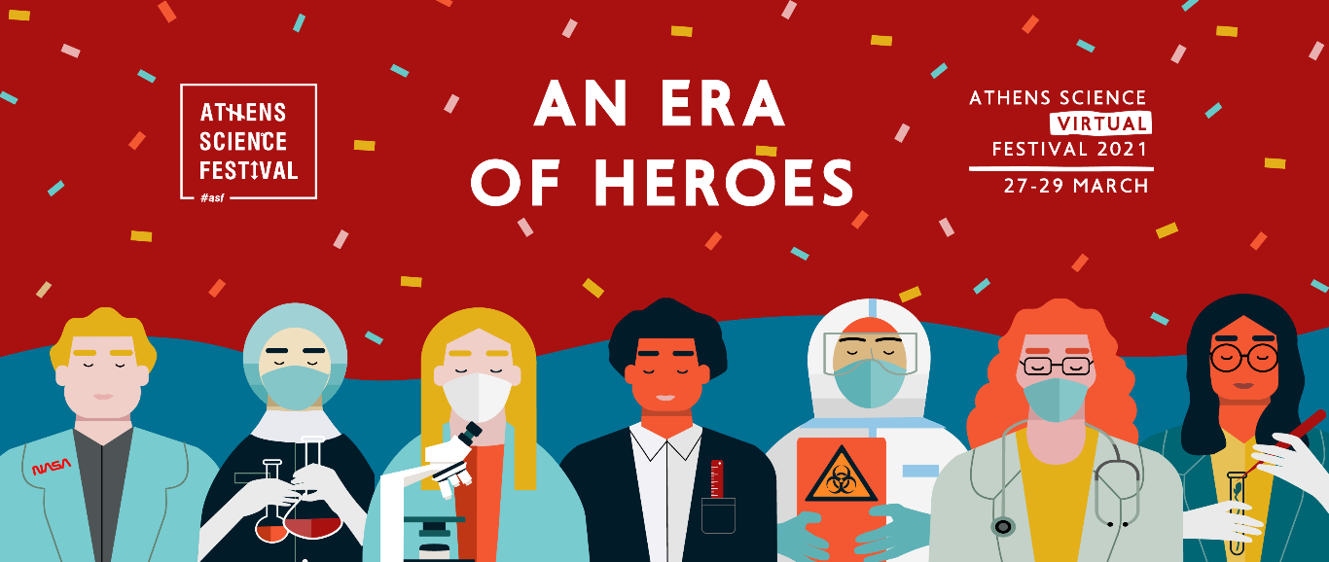

Athens Science Virtual Festival 2021
An era of heroes
27-29 Μarch, 2021
3 days of science, technology and innovation | 60 virtual activities sessions | 50 esteemed speakers from 8 countries | 3 Nobelists | 100 experiment demonstrations | celebrity science | chemistry shows | documentaries | free parallel activities for all ages

In times of hardship, heroes emerge! Athens Science Festival comes back with a new, digital format to introduce us to the "Era of heroes"! From March 27 to March 29, 2021, the largest science festival in the country will be back, online and in live broadcast, from the Technopolis City of Athens, to celebrate the latest developments in the fields of Science, Technology, and Innovation but also shine a light to the relationship between Art and Science.

The pandemic and its devastating effects on the entire planet bring to the forefront a new order of heroes, who stem primarily from the field of science! Their superpowers? Their unparalleled will to offer and their sense of duty towards their fellow humans, fueling them to fight every day in order to achieve the impossible; expand the boundaries of human knowledge, and provide viable solutions. Since not all heroes wear capes, Athens Science Festival 2021 will honor scientists of all fields!

Through a series of exciting live talks, workshops, experimental demonstrations, virtual exhibitions and other innovative digital activities, attendees will have the opportunity to get indroduced to some of the most distinguished scientists in the world. In this year’s Festival, everyone’s participation will be dynamic. Internet visitors, instead of being mere spectators of the programmed activities, will have the opportunity to participate online, thus turning the Festival into a digital, multidimensional scientific event!

A sneak-peak into the line-up of prominent scientists that will be hosted by the platform of Athens Science Festival 2021:

Peter Agre, the 2003 Nobel Chemistry winner, a renowned Professor and Director of the Johns Hopkins University Center for Malaria Research. He will talk about the importance of expanding the potential of medicine for the progress and development of humanity. In his talk, "Shaping a Better World through Medicine," Peter Agre will present medical science as a source of optimism for the future of our species.

Susan Schneider, an internationally renowned academic, distinguished philosopher and author of the successful book "Artificial You: AI and the Future of the Mind", will present the philosophical implications of technology and, in particular, the attempt to reproduce consciousness by artificial means, which is a pivotal issue that will concern us more and more in the near future.

The famous doctor and Professor of Physiology at the University of Maastricht, Mark Post, will offer us an innovative and environmentally friendly alternative to the way beef is produced. In his talk entitled "Delicious burger from...stem cells!", Dr. Post will elaborate on the technical challenges, opportunities and some amazing perspectives of the social impact of synthetic meat production in the laboratory.

Since 2014, Athens Science Festival has been continuously welcoming all those who are eager to gain scientific knowledge through different means and ways of learning, who want to enjoy the unique experience that their acquaintance with modern scientific and technological progress will give them and understand its inexhaustible achievements. The aim of this year's Festival is for everyone - regardless of age and gender - to recognize, appreciate and honor the role and contribution of scientists and the scientific community in our daily lives. "The era of Heroes" is here. We invite you to join us for another exciting science festival, ASF 2021, and explore the modern day heroes around us!

*The Athens Science Festival is organized on an annual basis by the educational organization “SciCo – Science Communication”, the British Council, and the Technopolis City of Athens with the invaluable contribution of a plethora of academic, research, and educational institutions. Strategic partner of the Athens Science Festival 2021 will be the National Technical University of Athens. The festival is conducted under the auspices of the Ministry of Digital Governance and the General Secretariat of Research and Innovation.

Stay tuned for more science news!
#asf
#ASF2021
#AthensScienceFestival

Information:
Saturday 27th until Monday 29th, March 2021
Attendee tickets from 5 euros | Free parallel activities
* The ticket pre-sale will start soon.
For more information: https://www.athens-science-festival.gr/en/
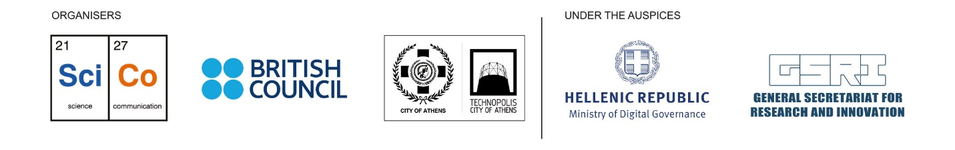

Technopolis of the City of Athens
Pireos str. 100, 118 54, Gazi
213 0109300
press@athens-technopolis.gr
